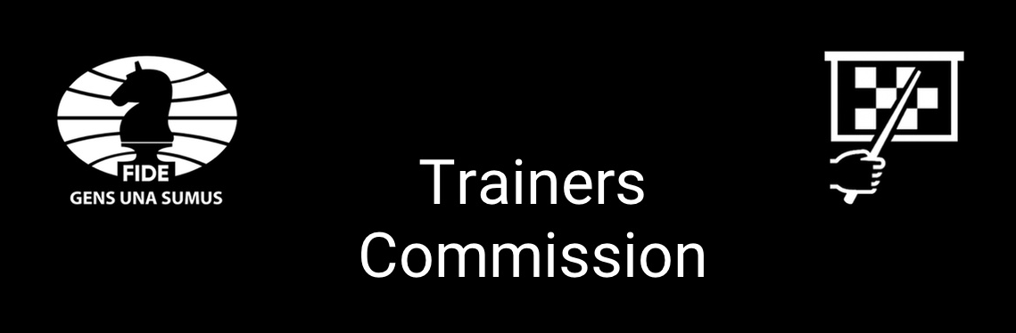

FIDE Trainer Awards 2023
Nomination Form
Nominated by | Name:  FIDE ID (if applicable):  E-mail:
Nominated Coach/Trainer/Captain | Name:  FIDE ID:  E-mail:
Justification

Categories  (Please select one award)  ……….. | - Mikhail Botvinnik Award for the best achievement by trainer(s) in Open Section competitions  - Vakhtang Karseladze Award for the best achievement by trainer(s) in women’s and/or girl’s competitions  - Mark Dvoretsky Award for the best achievement by trainer(s) in junior competitions  - Samual Reshevsky for the best achievement by a junior prodigy (U-14) player in competitions
Please, return the Nomination Form to
trainers@fide.com, by November 25, 2023.

